Pokhara University

Level: Bachelor | Semester – Spring | Year : 2006
Programme: BE |  | Full Marks: 100
Course: Engineering Mathematics III |  | Time : 3hrs.

Candidates are required to give their answers in their own words as far as practicable.
The figures in the margin indicate full marks.

Attempt all the questions.

 | - Define a matrix with its order. Show that (AB)/ = B/A/, where A and B are matrices of specified order.  OR  Show that  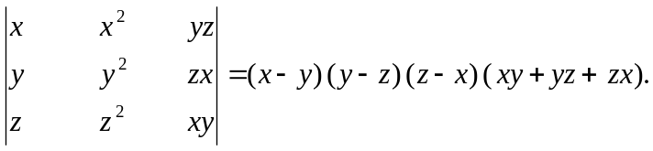  - Define rank of a matrix and find the rank of the following matrix: 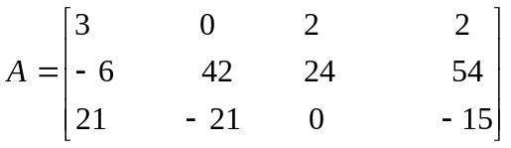 | 7  8
 | - When is a set of simultaneous equations said to be consistent? Show that the set of simultaneous equations 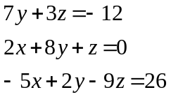  is consistent and solve it using Gauss elimination method.  - Find eigen value and eigen vector of the following matrix:  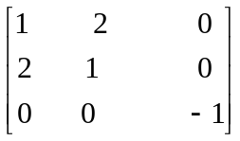 | 8  7
 | - Find the directional derivative of f at P along the direction of the vector 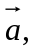where 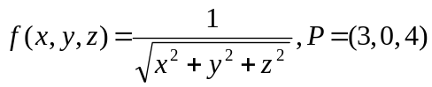 and 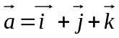 .  - If , find curl 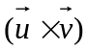 and grad 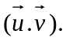 | 7  8
 | - What do you mean by exact integral? Show that the expression within the integral sign is exact and evaluate it 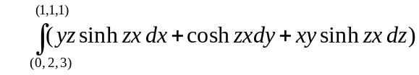  OR  By using Green’s theorem evaluate the following integral: 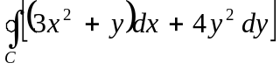, C is the boundary of the triangle with vertices (0, 0), (1, 0), (0, 2) in anti-clockwise direction.  - State Stokes theorem and evaluate:  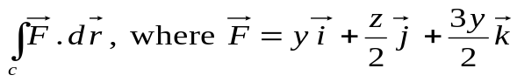, C is the boundary of the circle x² + y² + z² = 6z, z = x + 3. | 7  8
 | - Find the Fourier series of the function  = 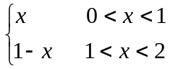  - Define an even and an odd functions. Find the Fourier series of the function 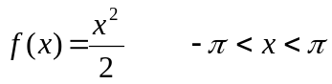. Hence show that 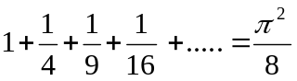 | 7  8
 | - Prove that the series 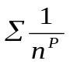 is convergent if P>1 and is divergent if P 1.  - Find the interval of convergence of an infinite series 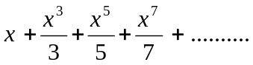  OR  Find expansion of log (1 + sin x) as far as the term in x⁴, by using Maclaurin expansion. | 7  8
 | Attempt all:  - If 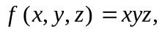show that 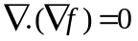  - Show that the infinite series 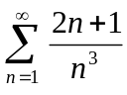is convergent.  - Find the smallest period of 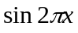.  - Find 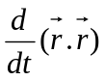 where 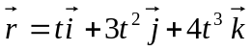  - Show that the transformation 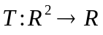 defined by 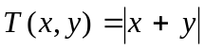 is not linear. | 2×5

